DATE: 12.04.2019
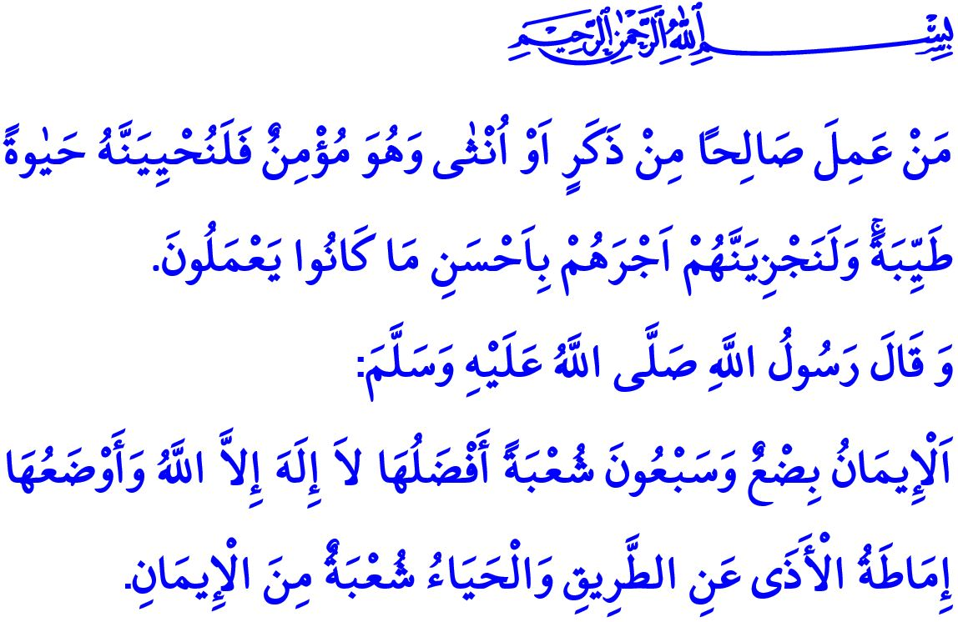
IMAN AND ITS REFLECTIONS ON OUR LIVES
Dear Muslims!
Iman means to believe in heart in the existence and oneness of Allah (swt), His angels, divine books, prophets, the Last Day, and that qada and qadar are controlled by Him. It means to acknowledge through heart and testify through tongue all the verities conveyed to people by the Prophet Muhammad (saw).
Honorable Believers!
In the case of the Prophet Adam (as), iman means not losing one's hope and not giving up on the struggle to deserve the Heaven despite failure. It means the spirit to stand up on one's feet again to make it to the end of the road despite toppling down along the way. It means constructing the ship of survival and salvation in the case of the Prophet Nuh (as). For a Muslim who gets on the board of the ship of iman, just by having faith in their Lord, will reach the eternal salvation after dropping anchor by the port of peace.
Iman is the remedy in the Prophet Ayyub's (as) house of suffering. It is the justice manifested at the Prophet Dawud's (as) tribunal. It is the knowledge and wisdom in the Prophet Sulayman's (as) realm. A person who is put on a trial through dire straits sometimes and wealthiness other times, should not forget that they have the capability to pass through those trials. For Allah (swt) holds a person responsible only to the extent they can afford. He certainly provides a way out when there appears to be no way out.
Honorable Believers!
Iman is manifested in the morals and manners of the Prophet Yusuf (as), and in the patience and prayers of the Prophet Yaqub (as). Iman is the source of the submission exhibited by the Prophet Ismail (as) through agreeing to his life being sacrificed by his father, and by the Prophet Ibrahim (as) through agreeing to sacrificing the life of his beloved son. It is a great uncompromisable and indispensible cause like in the case of the Prophet Muhammad Mustafa (saw), in whose right hand the Sun is offered and the Moon in his left hand.
Dear Muslims!
Iman is not a set of words, or emotions that cannot be manifested in the course of life. It is a unique power, springing up in heart and spreading all over the body, and being exhibited in the actions. There is a strong tie between iman and all the aspects of life. In this respect, the Prophet Muhammad (saw) referred to this fact when he said, "Iman has seventy something branches. “The most virtuous of them is 'La ilaha illallah (there is none worthy of worship except Allah)' and the least of which is removing something harmful from the road. And modesty (al-haya’) is a branch of faith.”
Dear Believers!
Iman is reflected on the essence of a person. It adds meaning to life. It draws a direction to follow. It helps to establish good relations with oneself, their family, society, and all the world of existence. It instills the consciousness to live a life in accordance with the purpose of creation.
It is manifested in one's words and actions. Mu'min (believer) is a good-mannered person from whose tongue and hand people are safe. They speak the truth when they talk. They have good intentions, are humble, honest, and merciful. They know that only that way they can get to and keep on the right path.
Iman is reflected on the face of a Muslim. A mu'min who is aware that exchanging a smile with people is regarded as sadaqa looks through loving and compassionate eyes. It refers to barakah (abundance) when manifested in one's livelihood, happiness in one's home, and salvation in the entirety of life.
Dear Muslims!
Having iman in heart truly and living a life in fulfillment of what iman requires one to do is the only way of becoming a Muslim and of having rewards in the Hereafter. Then, let us embellish our iman with good deeds and good morals, which will turn the world into a peaceful place, and the Hereafter into paradise. Let us endeavor to live up to and keep up the values we believe.
I would like to conclude this khutbah with the following statement of Allah the Almighty (swt) in which He gives glad tidings to people who have iman and live up to the requirements of it, “Whoever does righteousness, whether male or female, while he is a believer - We will surely cause him to live a good life, and We will surely give them their reward [in the Hereafter] according to the best of what they used to do.”

(Nasa'i, Iman, 16)
Nahl, 16/97. General Directorate of Religious Services

